Template – Adobe Sign Form Sequence with Multiple Signers
The template named “Template – Adobe Sign” is applicable to Anthology Student.

Purpose and Outcome
This template provides a form sequence and supporting workflow for a form sequence to be completed and signed by the student and a co-signer. The template shows how to use Adobe Sign components for fields such as Signature, Date Signed, and Initials for Signer 1 and Signer 2.
The sequence requires the following:
- A complete Student record must exist in the Anthology Student database.
- The student must have a Portal login to log into this authenticated sequence.
Upon completion of the sequence, the workflow creates a PDF of the form sequence and inserts the PDF into the Anthology Student Document Center.

Prerequisites
The template was built with Forms Builder using the applications listed below. The template is forward compatible with later versions of the listed applications.
Application | Compatibility Version
Forms Builder Designer and Renderer | Compatibility Matrix
Web Client for Anthology Student
Workflow Composer
Packages installed from Package Manager in Workflow Composer | Activities and Contracts (V2)  Contracts (V1)  Forms Builder Contracts  Note: Ensure that the Forms Builder Contracts package used in Workflow Composer is aligned with the version used in the Forms Builder. Additionally, confirm that both Activities and Contracts (V1) and Activities and Contracts (V2) packages in Workflow Composer match the versions used in the Student Web Client to avoid compatibility issues.  It depends on which product is being used. For example:  For CRM  Activities And Contracts (CRM)  Forms Builder Contracts
Workflow Tracking Database | N/A
Staff STS | 3.3.x

Prerequisite Settings
To test the multiple signature feature with Adobe Sign, the test environment needs to meet specific requirements. Adobe Sign will try to call APIs on Renderer when secondary signers complete their signing process via email. This feature is referred to as Webhook.
- If you are testing with an Adobe Sign account in test mode:
  - Renderer must be hosted on port 80 or 443.
  - Port 80 or 443 must be open on the firewall depending on which port Renderer is using for Adobe Sign to communicate. You can request an exception from your IT team for port 80 or 443 for an IP address range.
- If you are testing with a live Adobe Sign account:
  - Renderer must be hosted on port 443 (https).
  - If hosting Renderer on port 443 is not possible, an Adobe Sign representative for your account will have to make an exception.
To confirm that multi-signature forms are completing the workflow process, please confirm that Webhook responses are received and displayed in the log.

Step 1: Download and Import the Template
- Download the template file to your environment (local drive or network location).
- Log into Forms Builder and select the Form Designer tile.
- Click the Export/Import tile.
- Select the Import tab.
- Click Select exported file and navigate to the downloaded template file.
- Click Import.
Note: Import may fail if same files name is already available in environment or overwrite option.
- Export/Import

The following forms will be imported:
- Welcome
- CMC_Student_Personal_Adobe_Multi
- Default-Frame
- AdobeSignWait
- Default-Confirmation

Step 2: In Form Designer…
- From the Forms slide out, select the CMC_Student_Personal_Adobe_Multi form.
- Customize the form for your environment. Modify properties on fields/components to make them required, etc., or add/remove fields on form.
This form has multiple Adobe Sign components with Type property values such as Signature. Date, and Initials for Signer 1 (student) and Signer 2 (e.g., parent).
- Fields and Components
- Save the form.
- Adjust the Welcome and Default-Confirmation forms as appropriate for your institution.
- On the AdobeSignWait form, adjust the text of the HTML component.
Do not modify the Default-Frame form.

Step 3: In Sequence Designer…
- Locate the CMC_DEMO_AdobeSign_Multisign sequence in the Sequences pane.
- Click Save As to create a copy of the sequence/workflow and customize the copy for your use. This way you can always refer to the original sequence/workflow you downloaded.
- Optional - Customize the sequence properties for your environment.
- Optional - Add a custom style (theme) for your campus.
- Themes
- Select your saved sequence in the Sequences pane.
- In the Properties Pane, select End State Form “Default-Confirmation”.
- Save the sequence.

Step 4: In Workflow Composer…
- Open the workflow for your saved sequence.
- Opening Workflows for Sequences
- Explore the arguments, variables, states, and transitions to get an understanding of the workflow logic. This is a state machine workflow. Each form is a state. The arrows are transitions from one state to another.
- State Machine Workflows

- Double-click the Default-Frame state. This state has several LogLine and LogObject activities with Level = Error. You can remove these activities or change their Level settings to Information.
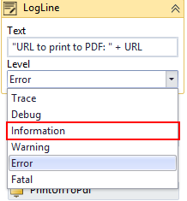
- If you changed any form names in the sequence, you need to update PrintUrlToPdf activity in the Default-Frame state to use form names or forms traversed instead of the Url string.
  - Updating a Form After Creation of a Sequence and PrintUrlToPdf

- Below the GetAdobeSignConfig activity in the Default-Frame state, you will find Assign activities for the following values:
Assign To | Value
AdobeSignConfig.EmailSubject | "CMC Campus DocuSign Testing"
AdobeSignDocument.DocumentId | 1
AdobeSignDocument.Name | AdobeSignDocument.Name
AdobeSignDocument.Content | Pdf
AdobeSignRecipient.FirstName | AdobeSignRecipient.FirstName
AdobeSignRecipient2.FirstName | "Mama"
AdobeSignRecipient2.LastName | studentEntity.LastName
AdobeSignRecipient2.Email | parentEmail
AdobeSignRecipient2.SignerId | "2"
- Modify the value for AdobeSignConfig.EmailSubject for your use case.
- Modify the values for AdobeSignRecipient2.FirstName and AdobeSignRecipient2.LastName, and AdobeSignRecipient2.Email for your use case.
Notice that the AdobeSignRecipient2.Email is assigned the parentEmail value. This value is passed as an argument from the Model property of the Text Box component in the Additional Signers section of the CMC_Student_Personal_Adobe_Multi form.
You could add Text Boxes to have users enter the first and last name of the second signer and pass the Model values as arguments to the workflow. You would then update the Assign statements for AdobeSignRecipient2.FirstName and AdobeSignRecipient2.LastName using the Model values of the Text Box components.

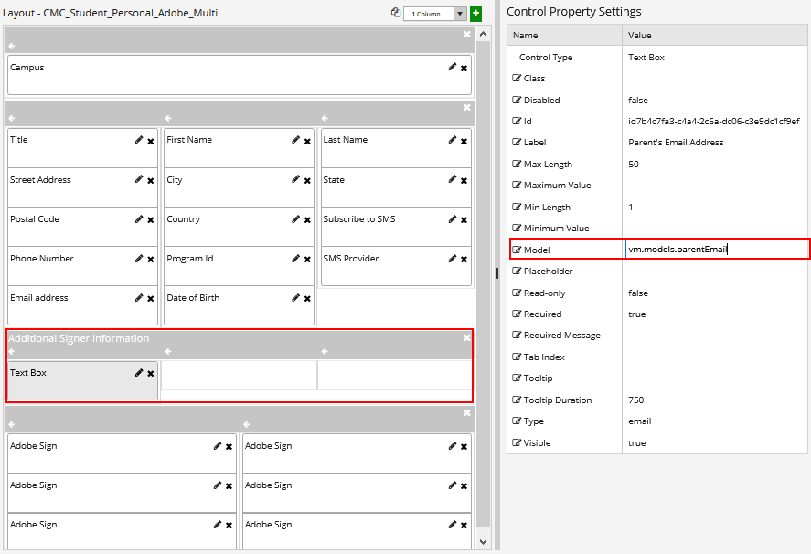

- Click the Done transition at the end of the workflow. At this point the workflow takes the signed PDF and updates the document center in the Anthology Student database.
This workflow section checks if the document is assigned to the student record.
- If it is, the workflow updates it by inserting and attaching the signed PDF and updating the document status.
- Otherwise, the workflow creates the document, attaches the signed PDF, and updates the document status.
Based on the values configured in your database, modify the CreateDocument activity to select appropriate values for Document Type and Document Status.
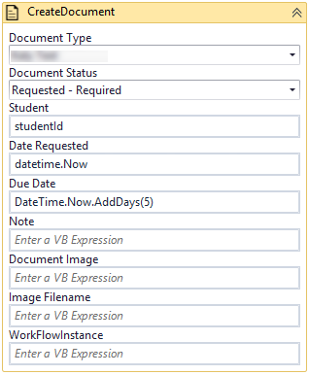
- Click the Publish button in the ribbon of Workflow Composer. Select the check box Enable This Workflow Version? and click Publish.
  - Saving and Publishing Workflowshttp://support.anthology.com/support/CampusNexus%20Workflow%20Help/Content/Workflow/CreateProspectInquiry.htm?Highlight=prospectInquiryEntity

Step 5: In Forms Renderer…
Select your sequence and try it out!
- Sequence List
- Find your CMC_DEMO_AdobeSign_Multisign sequence and copy the URL to the clipboard.
- Paste the URL into a browser and complete the form sequence.
- In Anthology Student, verify that the staff member’s address information is updated as specified in the form sequence.

Step 6: Lastly…
Once your updated sequence has been tested successfully, it is recommended that you disable the workflow for the original Template version.
- In Workflow Composer, in the Server section of the ribbon, click Open.
- Find the workflow named CMC_DEMO_AdobeSign_Multisign.
- Clear the Enabled check box and click Save.

